- Logo size should be bigger , neat and clean, (not clear readable)
- All web site font increase
- Together we give hope- Font colour slightly differ from original name of foundation on top page
- All the boxes of like treatment Aid should be slightly darker
- Foundation is not registered, removed registered word from everywhere, we will add later on after registration
Home image
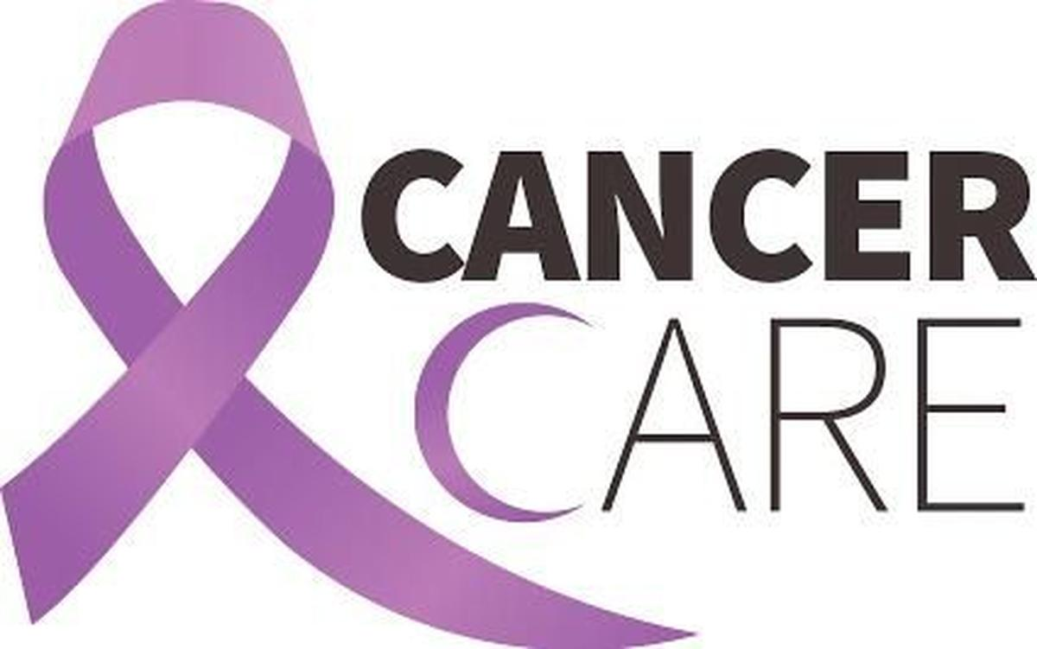
Volunteer page image
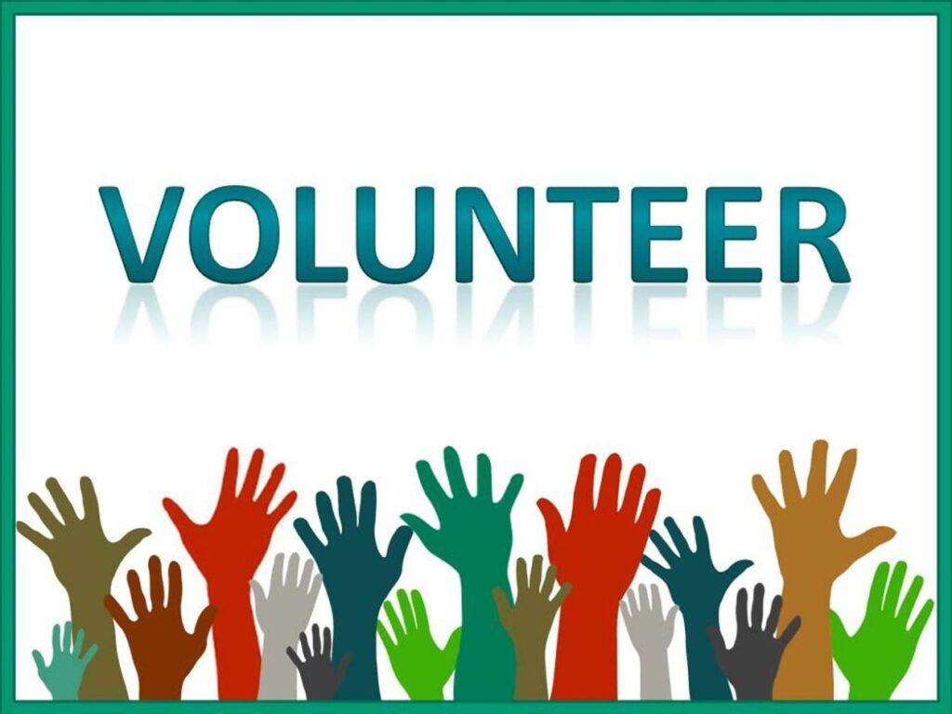
CSR Partnership image
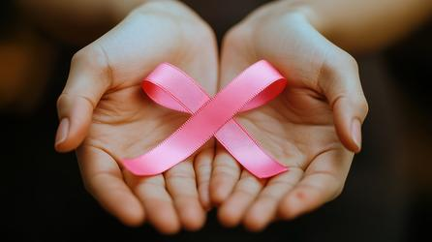

Patient Assistance Page


